**Consider the below Worker table:**

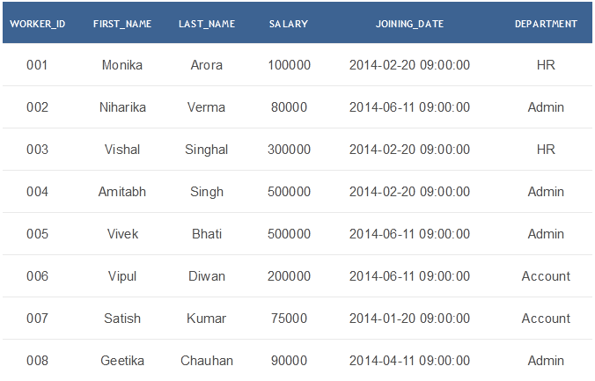

**Challenge-1:** Write an SQL query to print all Worker details from the Worker table order by FIRST_NAME Ascending and DEPARTMENT Descending.

**Ans:-**

Select *

From Worker

order by FIRST_NAME asc, DEPARTMENT desc;

**Challenge-2:** Write an SQL query to print details of workers excluding first names, “Vipul” and “Satish” from Worker table.

**Ans:-**

Select *

From Worker

Where FIRST_NAME not in(‘Vipul’,’Satish’);

**Challenge-3:** Write an SQL query to print details of the Workers whose SALARY lies between 100000 and 500000.

**Ans:-**

Select *

From Worker

Where SALARY between 100000 and 500000;

**Challenge-4:** Write an SQL query to print details of the Workers who have joined in Feb’2014.

**Ans:-**

Select *

From Worker

Where year(JOINING_DATE)=2014 and month(JOINING_DATE)=2;

**Challenge-5:** Write an SQL query to fetch worker names with salaries >= 50000 and <= 100000.

**Ans:-**

Select CONCAT(FIRST_NAME,’’,LAST_NAME)As Worker_Name,SALARY

From Worker

Where WORKER_ID In(Select WORKER_ID From Worker

Where SALARY between 50000 and 100000);